Run services on Intellij through Rancher

Download and Install Rancher
https://rancherdesktop.io/

Open Rancher desktop and load
More than 15mins

Intellij create server and connect Docker deamon
Connect to Dokcer deamon with
Docker for Windows
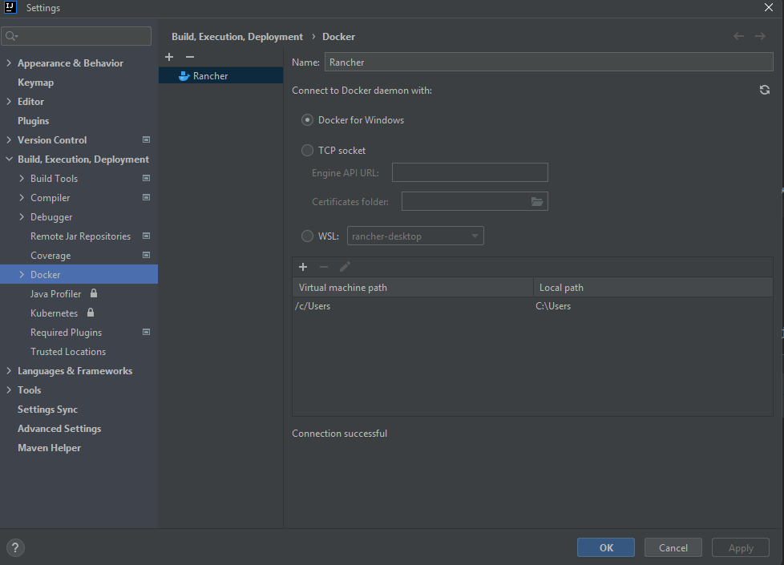

Set up Docker Registry (Optional)
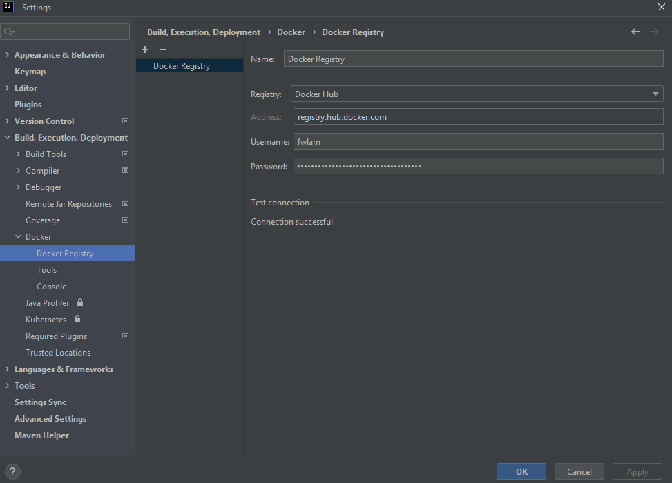

Fill in Docker executable in Docker > Tools
Docker executable: C:\Program Files\Rancher Desktop\resources\resources\win32\bin\docker.exe
Docker Compose executable: same
Press below red word to use docker v2
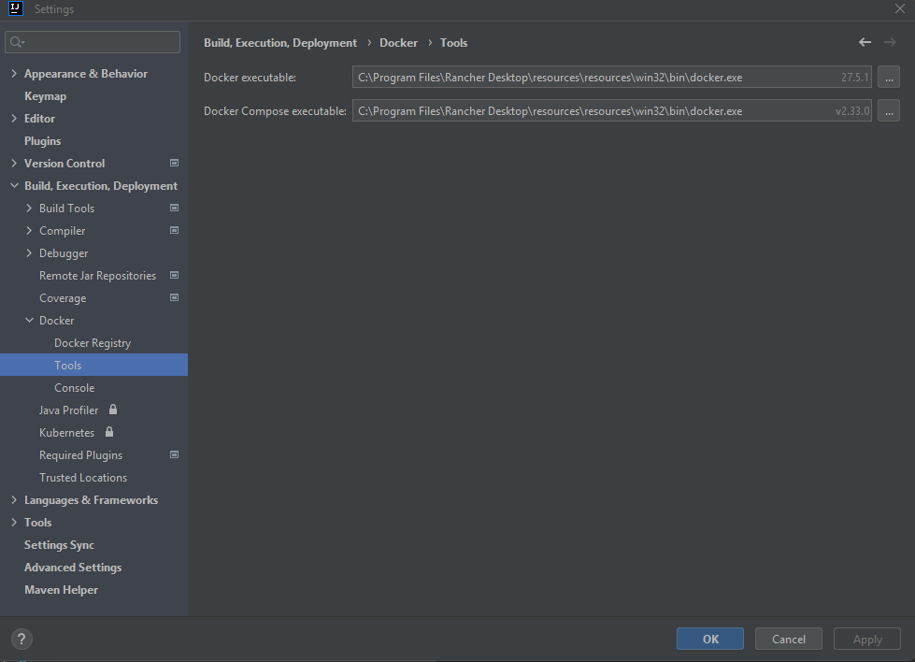

Edit Configuration
Run/Debug Configuration

Select server.
Select the compose files in the project.

In Docker compose up, click Modify and select Build > Always

Create main app (e.g. api) and infra configurations to separately restart or rebuild the main app after code change.
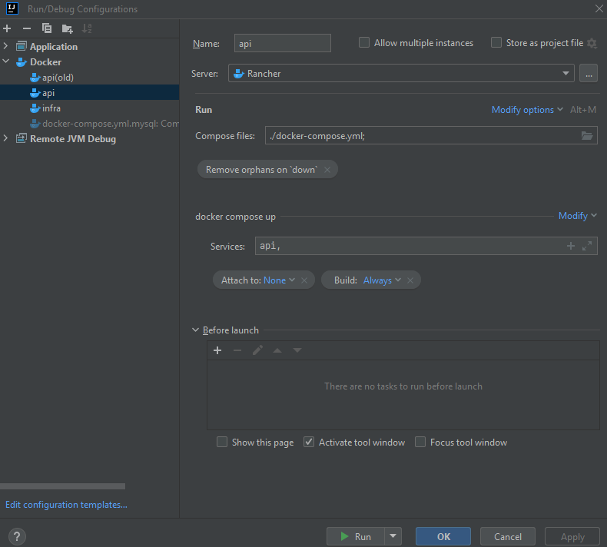
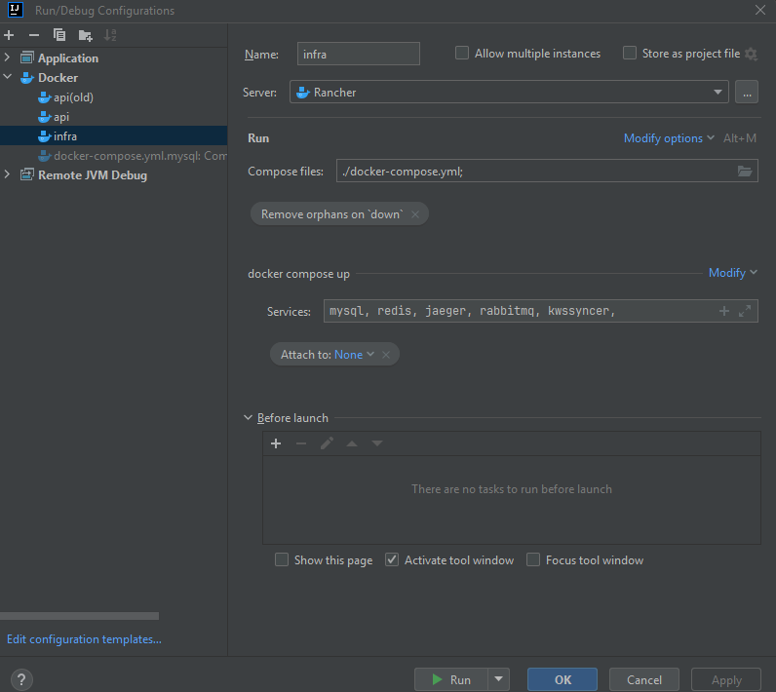
After running the app and infra, the server and services are shown in the tab Services.

The services can be restart, pause or stop via this GUI.
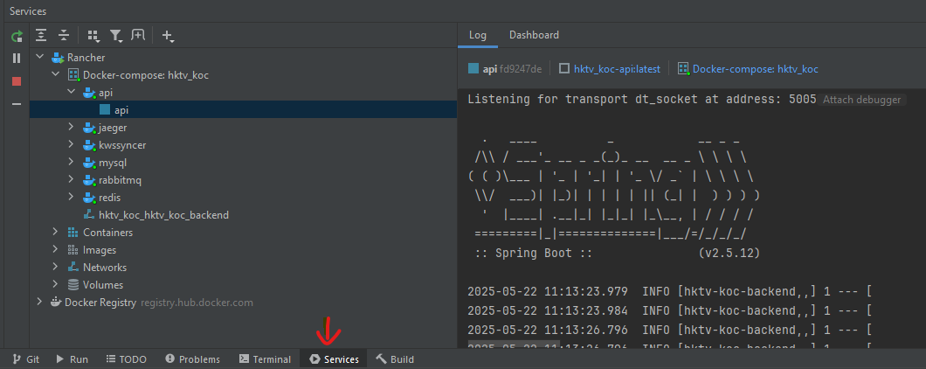

Additional commands:

wsl -l -v
Show distributions registered in this computer and show the versions
PS: wsl -l -v
NAME STATE VERSION
* Ubuntu Stopped 2
rancher-desktop Running 2
rancher-desktop-data Stopped 2

